**2.3 List of Use Case**

**2.3.1 <Librarians>Overview Use Case**

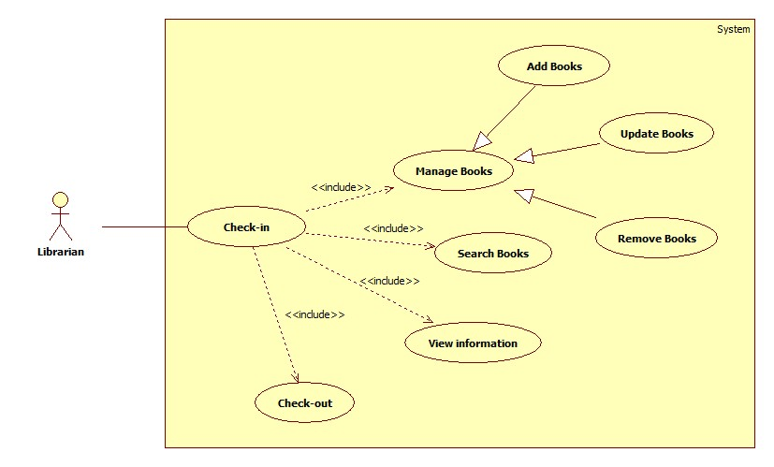

**Figure 1: <Librarians> Overview Use Case**

**2.3.1.1 <Librarians> Staff check-in**

**Use Case Diagram**

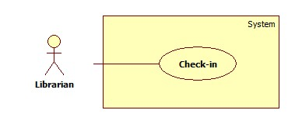

**Figure 2: <Librarian> Staff check-in**

**Use Case Specification**

|  |  |  |  |
| --- | --- | --- | --- |
| **USE CASE – LAR01** | | | |
| **Use Case No.** | LAR01 | **Use Case Version** | 2.0 |
| **Use Case Name** | Staff Check-in | | |
| **Author** | ThienTT | | |
| **Date** | 24/01/2015 | **Priority** | High |
| **Actor:**  - Librarian  **Summary:**  - This use case allows librarian to check-in the system.  **Goal:**  - Librarians login successful.  **Triggers:**  - At the login page, user scan the card with the distance is 3cm.  **Preconditions:**  - User must be librarian.  - Login page is display.  **Post Conditions:**   * Success: Login is successful. * Fail: Login fail and require user scan the card or input PIN again.   **Main Success Scenario:**   |  |  |  | | --- | --- | --- | | Step | Actor Action | System Response | | 1 | Go to Login page | Login page is display | | 2 | Scan the card with distance is 3cm | Authentication page is display | | 3 | User input PIN and click Submit | Display screen of librarian works |   **Alternative Scenario:**  **N/A**  **Exceptions:**   |  |  |  | | --- | --- | --- | | No | Actor Action | System | | 1 |  | Response | |  |  |  | |  |  |  |   **Relationships:** Mối quan hệ với các Use case khác nếu có trong quá trình xử lý, tuy nhiên nó không phải là abstract usecase  **Business Rules:**  - Thành phần mô tả các yêu cầu về mặt nghiệp vụ của use case.  - Tất cả các giả định về nghiệp vụ nếu có phải được ghi vào  - Chú ý tới sự chuyển đổi về trạng thái của dữ liệu cũng phải được ghi tại đây  - Các định nghĩa cũng cần làm rõ (sản phẩm nổi bật, sản phẩm sắp có là sản phẩm thế nào trong hệ thống)  - Các ràng buộc dữ liệu dưới hệ thống, các rule liên quan đến toàn vẹn dữ liệu  - Các qui trình, activities, quá trình chuyển đổi trạng thái của hệ thống | | | |

**2.3.1.2 <Librarians> Manage Books**

**Use Case Diagram**

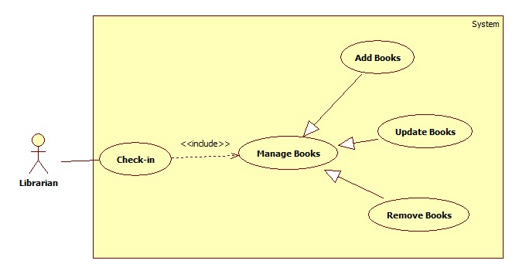

**Figure 2: <Librarian> Manage Books**

**2.3.1.2.1 <Librarian> Add books**

**Use Case Diagram**

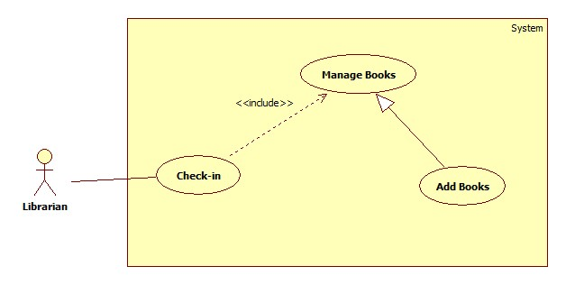

**Figure 2: <Librarian> Add Books**

**Use Case Specification**

|  |  |  |  |
| --- | --- | --- | --- |
| **USE CASE – LAR02** | | | |
| **Use Case No.** | LAR02 | **Use Case Version** | 2.0 |
| **Use Case Name** | Add New Books | | |
| **Author** | ThienTT | | |
| **Date** | 24/01/2015 | **Priority** | High |
| **Actor:**  - Librarian  **Summary:**  - This use case allows librarian add new books to database.  **Goal:**  - Librarians add a new book successful.  **Triggers:**  - At the screen of librarian works, user click “Add New Book” button.  **Preconditions:**  - User must be login to system with role Librarian.  - Display screen of librarian works.  - User chooses Add Book function.  **Post Conditions:**   * Success: New book will be added to database and the screen will show message “Book has been added successful” * Fail: Book won’t be added to database and the screen will show error message “Cannot add new book. Please check again”.   **Main Success Scenario:**   |  |  |  | | --- | --- | --- | | Step | Actor Action | System Response | | 1 | Go to screen of librarian works | Display screen of librarian works | | 2 | Click “Add New Book” | Display “Add New Book” form | | 3 | User input all information of new Book |  | | 4 | User click “Submit” button | Book will be added to database and the screen will show message “Add New Book successful” |   **Alternative Scenario:**  **N/A**  **Exceptions:**   |  |  |  | | --- | --- | --- | | No | Actor Action | System | | 1 |  | Response | |  |  |  | |  |  |  |   **Relationships:** Manage Books  **Business Rules:**  - Book to be added didn’t exist in database. | | | |

**2.3.1.2.2 <Librarian> Update Books**

**Use Case Diagram**

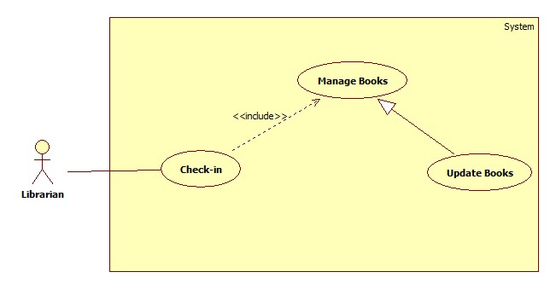

**Figure 2: <Librarian> Update Books**

**Use Case Specification**

|  |  |  |  |
| --- | --- | --- | --- |
| **USE CASE – LAR03** | | | |
| **Use Case No.** | LAR03 | **Use Case Version** | 2.0 |
| **Use Case Name** | Update Books | | |
| **Author** | ThienTT | | |
| **Date** | 24/01/2015 | **Priority** | Normal |
| **Actor:**  - Librarian  **Summary:**  - This use case allows librarian to update information of books.  **Goal:**  - New information of books will be update to database.  **Triggers:**  - At the screen of librarian works, user click “Update Book” button.  **Preconditions:**  - User must be login to system with role Librarian.  - Screen of librarian works is displayed.  - User chooses Update Book function.  **Post Conditions:**   * Success: New information of books will be updated to database and the screen will show message “Book has been updated successful”. * Fail: Information of book won’t be changed and the screen will show message “Update book failed. Please try again”.   **Main Success Scenario:**   |  |  |  | | --- | --- | --- | | Step | Actor Action | System Response | | 1 | Go to screen of librarian works | Display screen of librarian works | | 2 | Click “Update Book” | Display “Update Book” form | | 3 | User input all information of book |  | | 4 | User click “Submit” button | Information will be updated to database and the screen show message “Updated books successful” |   **Alternative Scenario:**  **N/A**  **Exceptions:**   |  |  |  | | --- | --- | --- | | No | Actor Action | System | | 1 |  | Response | |  |  |  | |  |  |  |   **Relationships:** Manage Books  **Business Rules:**  - Thành phần mô tả các yêu cầu về mặt nghiệp vụ của use case.  - Tất cả các giả định về nghiệp vụ nếu có phải được ghi vào  - Chú ý tới sự chuyển đổi về trạng thái của dữ liệu cũng phải được ghi tại đây  - Các định nghĩa cũng cần làm rõ (sản phẩm nổi bật, sản phẩm sắp có là sản phẩm thế nào trong hệ thống)  - Các ràng buộc dữ liệu dưới hệ thống, các rule liên quan đến toàn vẹn dữ liệu  - Các qui trình, activities, quá trình chuyển đổi trạng thái của hệ thống | | | |

**2.3.1.2.3 <Librarian> Remove Books**

**Use Case Diagram**

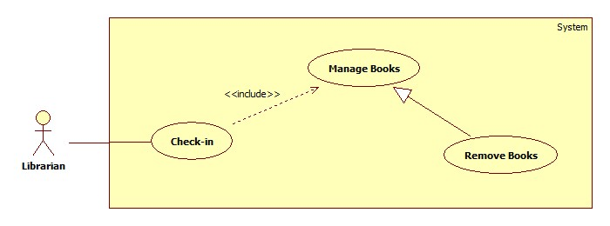

**Figure 2: <Librarian> Remove Books**

**Use Case Specification**

|  |  |  |  |
| --- | --- | --- | --- |
| **USE CASE – LAR04** | | | |
| **Use Case No.** | LAR04 | **Use Case Version** | 2.0 |
| **Use Case Name** | Remove Books | | |
| **Author** | ThienTT | | |
| **Date** | 24/01/2015 | **Priority** | Normal |
| **Actor:**  - Librarian  **Summary:**  - This use case allows librarian to remove books.  **Goal:**  - Book will be removed from database and not exist in system.  **Triggers:**  - At the View List Book, user select books and click “Remove” button.  **Preconditions:**  - User must be login to system with role Librarian.  - List books are displayed.  - User chooses Remove Book function.  **Post Conditions:**   * Success: Books will be removed from the database and the screen will show message “Removed book successful” * Fail: Books cannot remove and the screen will show error message “Removed fail. Please check again”.   **Main Success Scenario:**   |  |  |  | | --- | --- | --- | | Step | Actor Action | System Response | | 1 | Go to View List Books | Show list books | | 2 | User select books want to remove book |  | | 3 | User click “Remove Book” button | Book will be removed from database and show message “Removed success” |   **Alternative Scenario:**  **N/A**  **Exceptions:**   |  |  |  | | --- | --- | --- | | No | Actor Action | System | | 1 |  | Response | |  |  |  | |  |  |  |   **Relationships:** Manage Book  **Business Rules:**  - Thành phần mô tả các yêu cầu về mặt nghiệp vụ của use case.  - Tất cả các giả định về nghiệp vụ nếu có phải được ghi vào  - Chú ý tới sự chuyển đổi về trạng thái của dữ liệu cũng phải được ghi tại đây  - Các định nghĩa cũng cần làm rõ (sản phẩm nổi bật, sản phẩm sắp có là sản phẩm thế nào trong hệ thống)  - Các ràng buộc dữ liệu dưới hệ thống, các rule liên quan đến toàn vẹn dữ liệu  - Các qui trình, activities, quá trình chuyển đổi trạng thái của hệ thống | | | |

**2.3.1.3 <Librarian> View student information**

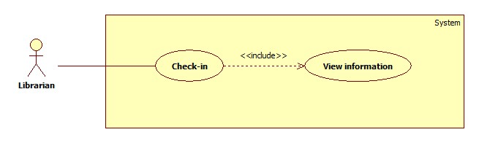

**Figure 2: <Librarian> View student information**

**Use Case Specification**

|  |  |  |  |
| --- | --- | --- | --- |
| **USE CASE – LAR05** | | | |
| **Use Case No.** | LAR05 | **Use Case Version** | 2.0 |
| **Use Case Name** | View Student Information | | |
| **Author** | ThienTT | | |
| **Data** | 27/01/2015 | **Priority** | Normal |
| **Actor:**  - Librarian  **Summary:**  - This use case allows librarian to view student.  **Goal:**  - Information of student will be display on screen.  **Triggers:**  - At the screen of librarian works, user scan the card with the distance is 3cm.  **Preconditions:**  - User must be login to system with role Librarian.  - Librarian’s work screen is displayed.  - User chooses View information function.  **Post Conditions:**   * Success: Display all information of student. * Fail: Don’t show information of student and the screen will show message “Cannot view information. Please scan again”   **Main Success Scenario:**   |  |  |  | | --- | --- | --- | | Step | Actor Action | System Response | | 1 | Go to screen of librarian works | Display screen of librarian works | | 2 | Scan the card with distance is 3cm | All information will show |   **Alternative Scenario:**  **N/A**  **Exceptions:**   |  |  |  | | --- | --- | --- | | No | Actor Action | System | | 1 |  | Response | |  |  |  | |  |  |  | | | | |

**2.3.1.4 <Librarian> Search Books**

**Use Case Diagram**

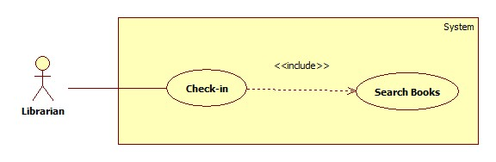

**Figure 2: <Librarian> Search Books**

**Use Case Specification**

|  |  |  |  |
| --- | --- | --- | --- |
| **USE CASE – LAR06** | | | |
| **Use Case No.** | LAR06 | **Use Case Version** | 2.0 |
| **Use Case Name** | Search Books | | |
| **Author** | ThienTT | | |
| **Data** | 27/01/2015 | **Priority** | Normal |
| **Actor:**  - Librarian  **Summary:**  - This use case allows librarian find a book.  **Goal:**  - Information of book will be show.  **Triggers:**  - At the screen of librarian works, user input name of book and press enter or click “Search” button.  **Preconditions:**  - User must be login to system with role Librarian.  - Screen of librarian works is displayed.  - User chooses Search book function.  **Post Conditions:**   * Success: Display all information of book. * Fail: Don’t show information of book and the screen will show message “Book not found. Please check again”   **Main Success Scenario:**   |  |  |  | | --- | --- | --- | | Step | Actor Action | System Response | | 1 | Go to screen of librarian works | Display screen of librarian works | | 2 | Input name of book |  | | 3 | Press Enter or click “Search” button | All information of book will show. |   **Alternative Scenario:**  **N/A**  **Exceptions:**   |  |  |  | | --- | --- | --- | | No | Actor Action | System | | 1 |  | Response | |  |  |  | |  |  |  | | | | |